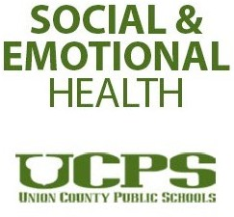

The Student Support Department has developed a resource guide for parents addressing social emotional learning and well-being skills. This guide provides a quick overview of topics along with sample resources and links to additional materials that can be used in school and at home with students across all grade levels. Please feel free to reach out to a member of student support with specific questions or concerns. Additional pages will be added covering new topics in the spring.

**Table of Contents**

The Power of Positivity p. 3 – 4

Feelings and Mood p. 5 - 6

Problem-Solving p. 7

Self-Regulation p. 8 – 10

Resources p. 11

Updated 1/11/2021

# The Power of Positivity

Positive thinking leads to a positive outlook. Practice reframing negative situations to find the positive solution. This will help better equip children to deal with conflict and differences in a productive manner. Positive thinking is also linked with higher self-confidence and self- efficacy.

Positive Words Free Rewards

Mood Booster 30 Day Challenge

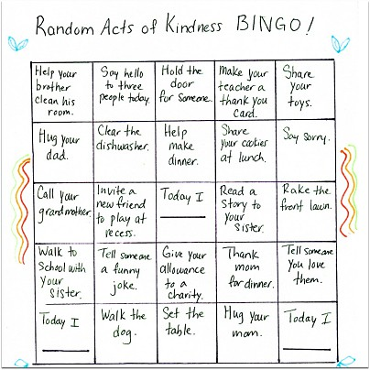

Use this sample to help generate your BINGO board.

[How Full Is Your Bucket,](https://www.amazon.com/How-Full-Your-Bucket-Kids/dp/1595620273) by Tom Rath is a great book to learn about positive thinking.

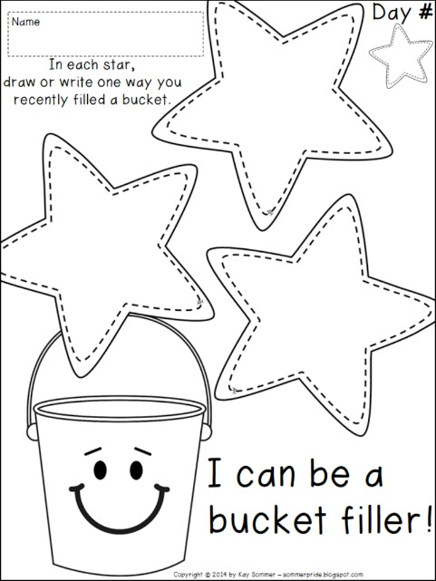

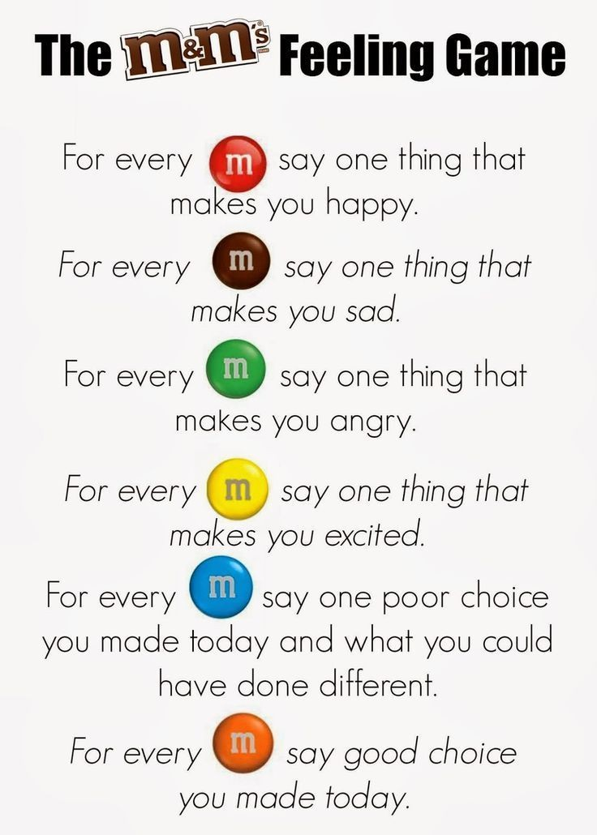

# Feelings and Mood

Learning about our feelings is crucial to social emotional learning and well-being. It is important to learn how to verbalize how we feel as well as what our body feels like with different feelings. Equally as important is teaching children that there is no such thing as a ‘bad’ feeling, rather there are positive and negative feelings which everyone experiences.

Do a daily feelings check to gauge where you and your child(ren) fall on the mood meter. For more information check out [colors-of-our-emotions](https://www.marcbrackett.com/the-colors-of-our-emotions/)

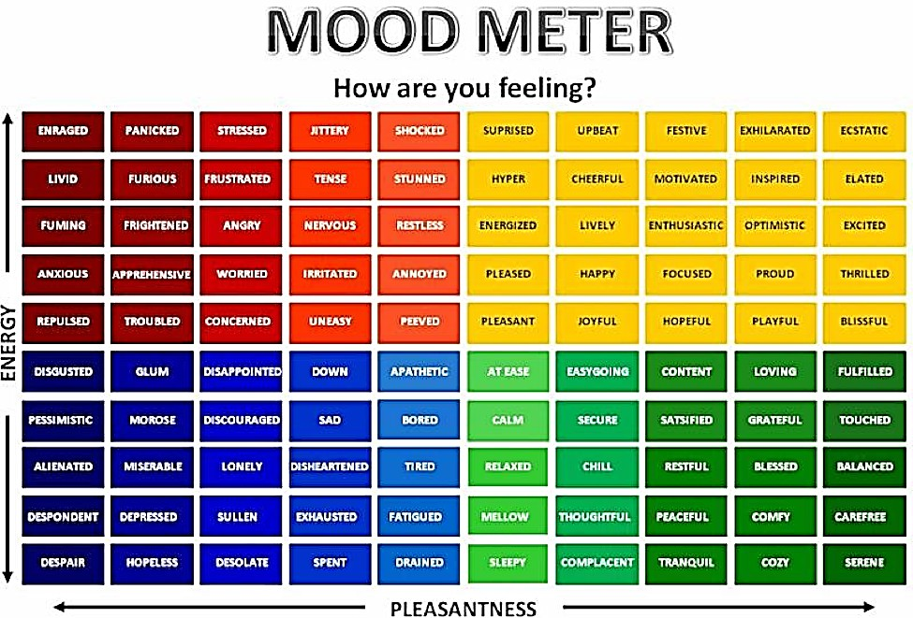

**Visual Example of a Mood Meter**

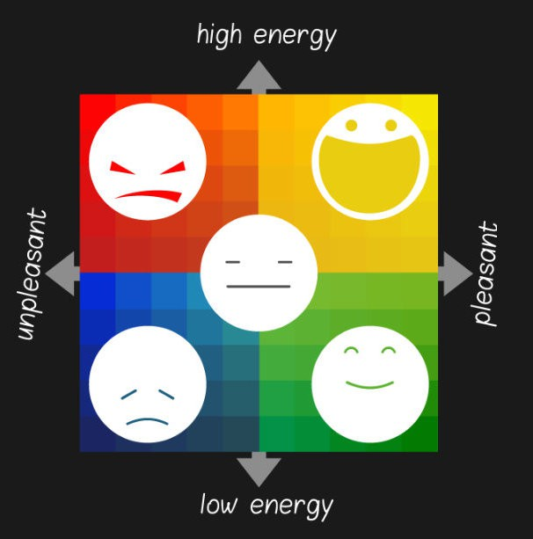

**Zones of Regulation- Connecting Words and Feelings**

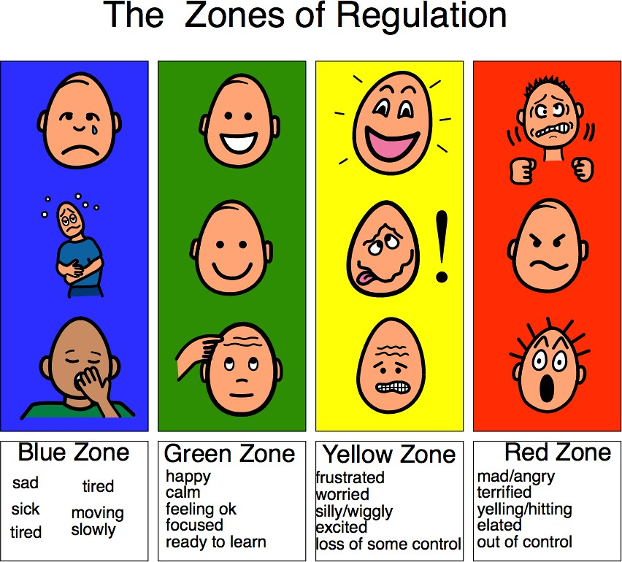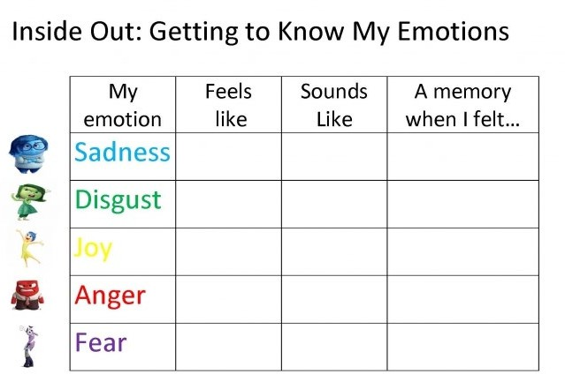

These are just a few options to help identify feelings and learn how the body feels. Learning how the body feels will help children better recognize when they are becoming upset, angry, or frustrated. Knowing this in turn can help de-escalate situations because children can learn coping strategies to proactively reduce negative feelings.

# Problem Solving

Does your child have big reactions to small issues? This is a great resource to help learn how to regulate emotions and have appropriate reactions to problems.

[**Social Thinking Problem Solving Strategy**](https://www.socialthinking.com/Articles?name=learning-control-emotional-reactions-part-problem-solving)

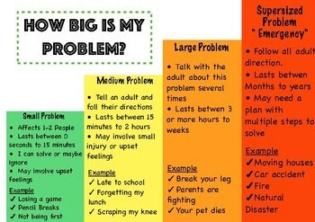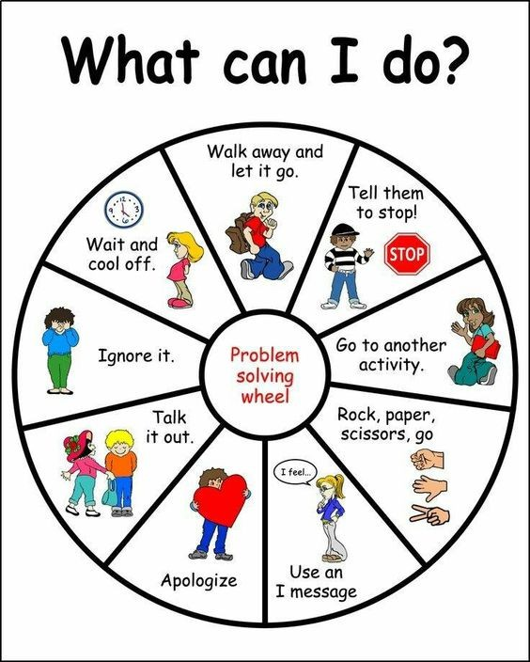

# Self-Regulation

Self-regulation is the ability to manage your own emotions. For younger children, co-regulating can be a useful way to model how to regulate with them. For example, coloring with your children is an easy way to co-regulate. For children who are able, self-regulation is a quick and easy way to feel grounded. They can color, draw, write, walk, or any other method they find helpful.

Feeling stressed, overwhelmed, antsy? Check out some self-soothing regulation tools to help relieve those feelings.

<https://www.calm.com/> <https://my.life/> <https://www.gonoodle.com/>

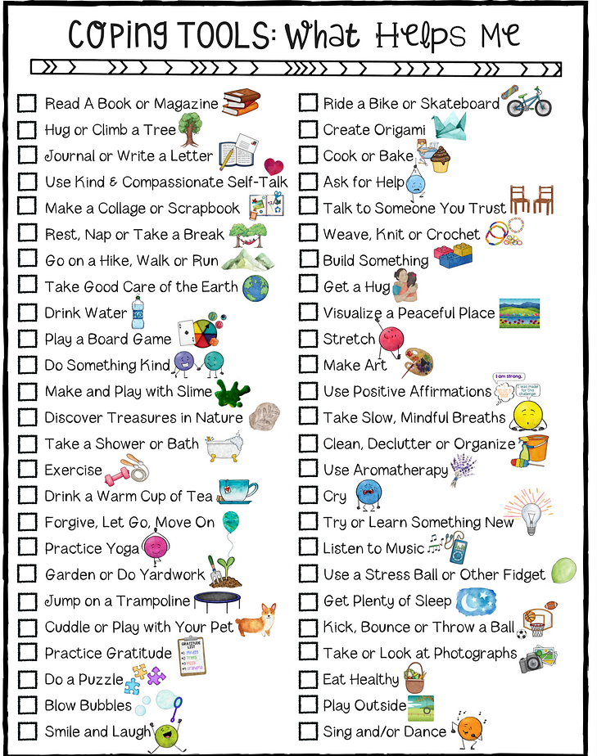

The Cope-cake is a great way to identify what works to help calm your child. This sample can be used to generate ideas for your child. Use this sample to help generate one you can use.

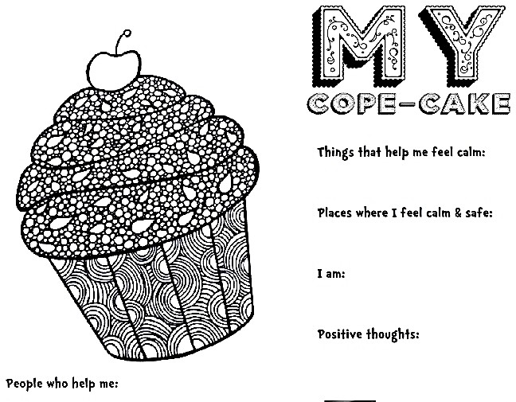

[My Mouth is a Volcano](https://www.amazon.com/dp/B08QS7DN7M/ref%3Ddp-kindle-redirect?_encoding=UTF8&btkr=1), book by Julia Cook is a great tool to help reduce impulsive behaviors.

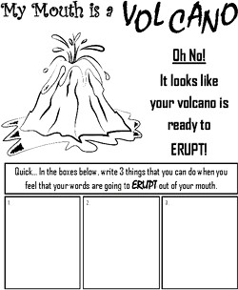

**Identifying Feelings and Actions You Can Take**

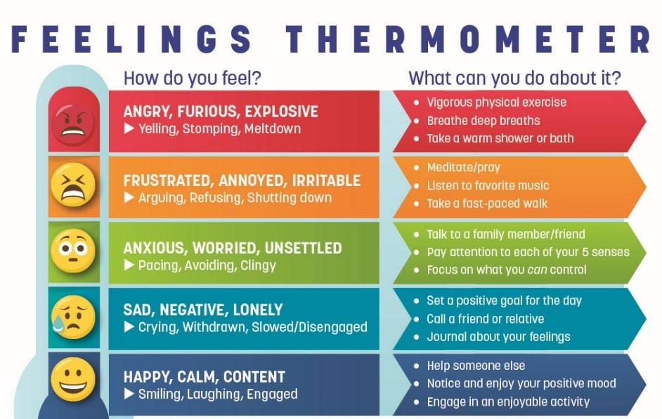

**How Your Body Feels**

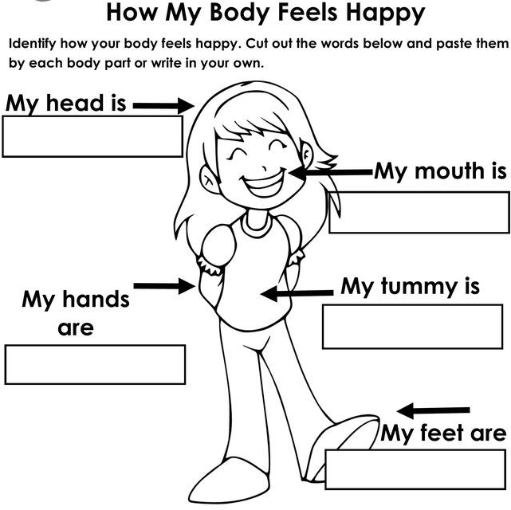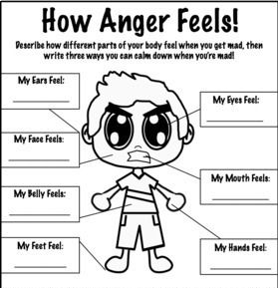

Help your child learn how to connect how their body feels to how their mind feels. For example, when I am feeling mad, I ball up my fists and tense my shoulders. When I am nervous, I bite my nails and tap my leg.

**Resources**

[SEL Parent Resources](https://www.edutopia.org/SEL-parents-resources) [Coping Skills](https://confidentparentsconfidentkids.org/)

[School Support and Structure](https://www.greatschools.org/gk/coronavirus-school-closure-support/) [Confident parents confident kids](https://confidentparentsconfidentkids.org/about-the-blog/)